D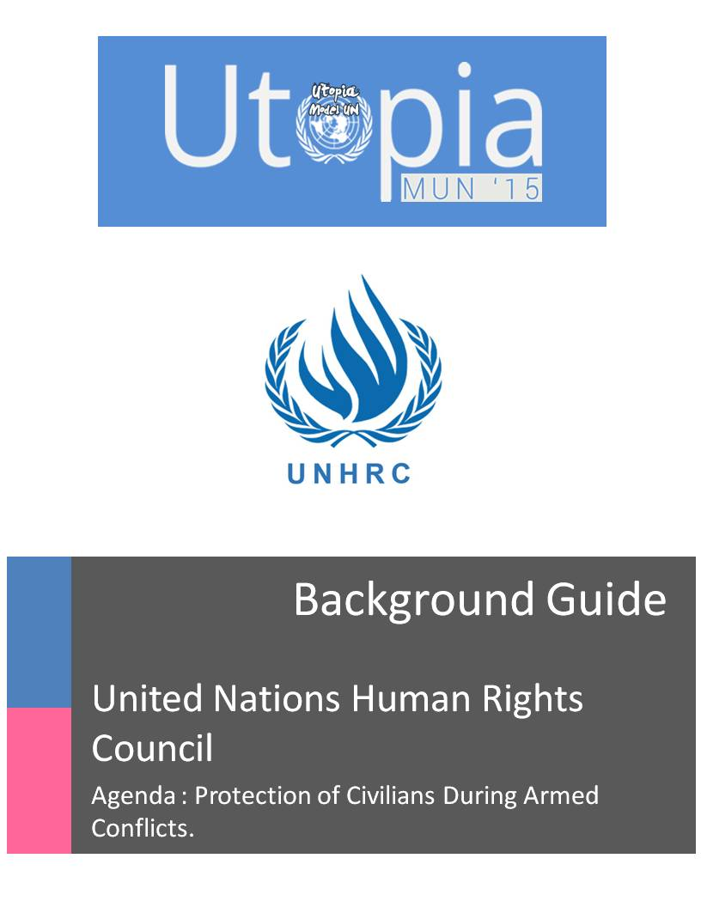Message from the Executive Board

Respected Delegates,

It is our utmost pleasure to welcome you all to this forum to discuss and deliberate upon the grave issues that mankind and all beings alike are faced with today.

We are here to reaffirm, reiterate and resolve.

This Background Guide is designed to be the beginning of your research process, and by no means should encompass the scope of your research. The agenda of the committee is open-ended but requires focused research in certain key aspects that have been listed in this guide. We urge all members of the committee to take the time to read the background guide and use it as a starting point for their research. Each delegate is requested to come to the conference with an open mind, ready to meet and work with new people, and not be afraid of speaking in front of the committee, drafting a working paper, or supporting/opposing a draft resolution.

We hope this background guide acts as an effective starting point for your research and please feel free to contact the Executive Board for any further clarifications.

*Please note that nothing mentioned in this background may be used as established fact in committee without the presentation of a credible news source. Any substance mentioned henceforth may act only as a source for your basic understanding of the agenda.


Regards

Executive Board


You may contact us on the following email id for in case of any queries or concerns –

hrcutopia15@gmail.com

1 | H u m a n R i g h t s C o u n c i l
Acceptable sources of Information

Within the committee information can be quoted from the following sources:

- News Sources:

  - Reuters – Any Reuters article which clearly makes mention of the fact or is in contradiction of the fact being stated by a delegate in council.
  - State operated News Agencies – These reports can be used in the support of or against the State that owns the News Agency. These reports, if credible or substantial enough, can be used in support of or against any Country as such but in that situation, they can be denied by any other country in the council. The Executive Board shall remain neutral towards the credibility of these reports. Some examples are -
    - RIA Novosti (Russia)

    - IRNA (Iran)

    - BBC (United Kingdom)

    - Xinhua News Agency and CCTV (P.R. China)

- Government Reports: These reports can be used in a similar way as the State Operated News Agencies reports and can, in all circumstances, be denied by another country. However, the essential difference is that if a government report is being denied by a certain country, it can still be accepted by the Executive Board as a credible source of information. Some examples are,

  - Government Websites like the State Department of the United States

  - Ministry of Foreign Affairs of various nations

  - Permanent Representatives to the United Nations

  - Multilateral Organizations like the NATO, ASEAN, OPEC, BRICS, SCO etc.

- UN Reports: All UN Reports and publications are considered as credible sources of information.

  - UN Bodies: Like the United Nations Security Council, United Nations General Assembly, United Nations Human Rights Council etc.
  - UN Affiliated bodies like the International Atomic Energy Agency, International Committee of the Red Cross etc.


Under no circumstances will sources like Wikipedia, Amnesty International, Human Rights Watch, Al-Jazeera or newspapers like The Guardian, The Times of India etc. be accepted.

2 | H u m a n R i g h t s C o u n c i l
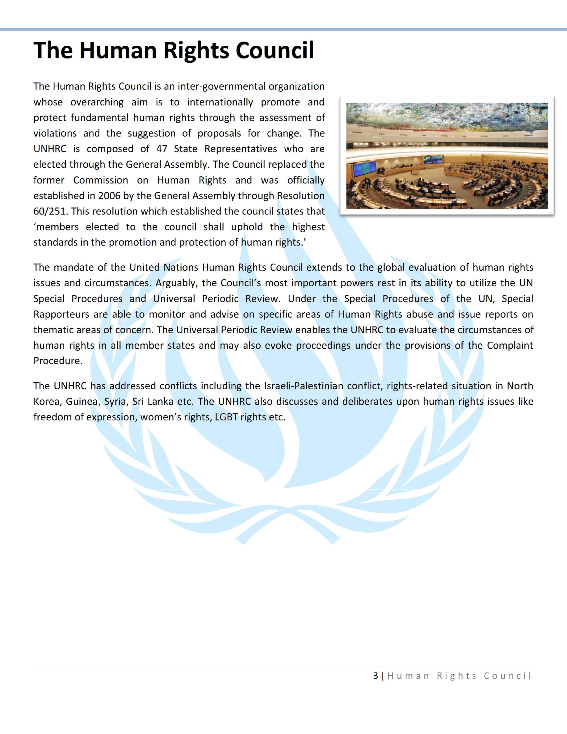
International Humanitarian Law

International humanitarian law (IHL) is that branch of international law which seeks to limit the effects of armed conflict by protecting persons who are not participating in hostilities, and by restricting and regulating the means and methods of warfare available to combatants. IHL is inspired by considerations of humanity and the mitigation of human suffering. "It comprises a set of rules, established by treaty or custom, that seeks to protect persons and property/objects that are (or may be) affected by armed conflict and limits the rights of parties to a conflict to use methods and means of warfare of their choice." In this background guide, 2 important documents relating to IHL namely, The Universal Declaration of Human Rights (UDHR) and The Geneva Convention have been explained below.

The Universal Declaration of Human Rights (UDHR)
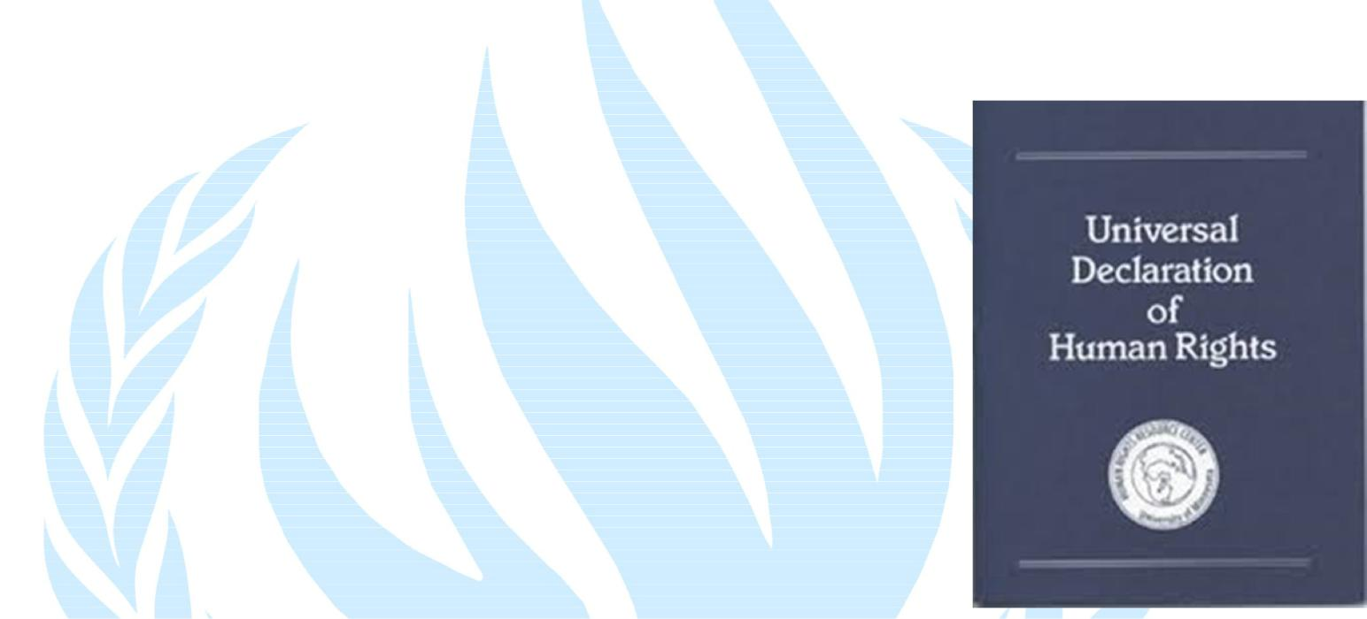
The Universal Declaration of Human Rights is a declaration adopted by the United Nations General Assembly on 10th December 1948. The Declaration consists of thirty articles which have been elaborated in subsequent international treaties, regional human rights instruments, national constitutions, and other laws.

Articles 1 and 2 are the foundation blocks. Articles 3–11 constitute rights of the individual such as the right to life and the prohibition of slavery. Articles 6-11 refer to the legality of human rights with specific remedies cited for their defense when violated. Articles 12–17 constitute the rights of the individual in civil and political society (such as freedom of movement). Articles 18–21 deal with spiritual and public freedoms like freedom of association, thought, conscience, and religion. Articles 22–27 set out social, economic, and cultural rights.
The Geneva Conventions
The Geneva Conventions comprise of four treaties, and three additional protocols, that establish the standards of international law for humanitarian treatment during war. In 1993, the UN Security Council adopted a report which concluded that the Geneva Conventions had passed into the body of customary international law, thus making them binding on non-signatories to the Conventions whenever they engage in armed conflicts.

Within these conventions, the 4th treaty affords humanitarian protection of civilians in a war zone. Each article laid out in this treaty is binding all nations that are a part of the UN. Some important articles in this treaty are -

Article 3 (common to all 4 treaties) |  |  | Article 31
 | Article 4 |  | Article 33
 | Article 27 |  | Article 51

4 | H u m a n R i g h t s C o u n c i l
Armed Conflicts

An armed conflict is a contested incompatibility which concerns government and/or territory where the use of armed force between two parties, of which at least one is the government of a state, results in at least 25 battle-related deaths.

Types of Armed Conflicts
International armed conflict
Common Article 2 to the Geneva Conventions of 1949 states that:
"In addition to the provisions which shall be implemented in peacetime, the present Convention shall apply to all cases of declared war or of any other armed conflict which may arise between two or more of the High Contracting Parties, even if the state of war is not recognized by one of them.”
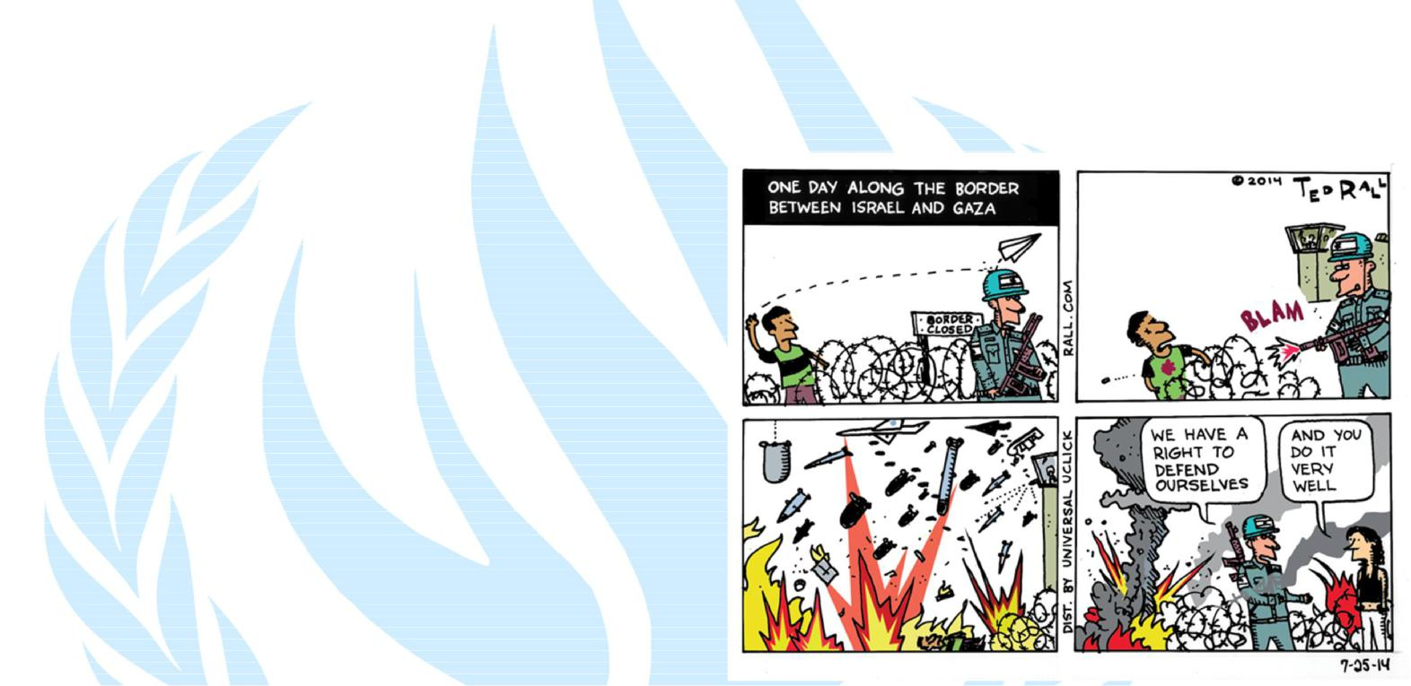
The Convention shall also apply to all cases of partial or total occupation of the territory of a High Contracting Party, even if the said occupation meets with no armed resistance". According to this provision, IACs are those which oppose "High Contracting Parties", meaning States. An IAC occurs when one or more States have recourse to armed force against another State, regardless of the reasons or the intensity of this confrontation. Relevant rules of IHL may be applicable even in the absence of open hostilities. Moreover, no formal declaration of war or recognition of the situation is required. The existence of an IAC, and as a consequence, the possibility to apply International Humanitarian Law to this situation,
depends on what actually happens on the ground. It is based on factual conditions.
Non-international armed conflict
A more restrictive definition of NIAC was adopted for the specific purpose of Additional Protocol II of the Geneva Conventions. This applies to armed conflicts "which take place in the territory of a state between its armed forces and dissident armed forces or other organized armed groups which, under responsible command, exercise such control over a part of its territory.” This definition is narrower than the notion of NIAC under common Article 3 in two aspects. Firstly, it introduces a requirement of territorial control, by providing that non-governmental parties must exercise such territorial control "as to enable them to carry out sustained and concerted military operations and to implement this Protocol". Secondly, Additional Protocol II expressly applies only to armed conflicts between State armed forces and dissident armed forces or other organized armed groups. Contrary to common Article 3, the Protocol does not apply to armed conflicts occurring only between non-State armed groups.
5 | H u m a n R i g h t s C o u n c i l
Protection of Civilians during Armed Conflicts

All military conflicts lead to the loss of lives. Nevertheless, the lives lost are not only of soldiers. In every conflict, not only combatants and killed but also civilians. In other words, non-combatants are always an unavoidable casualty of war. In fact, over 75% of the causalities in a war are civilians.
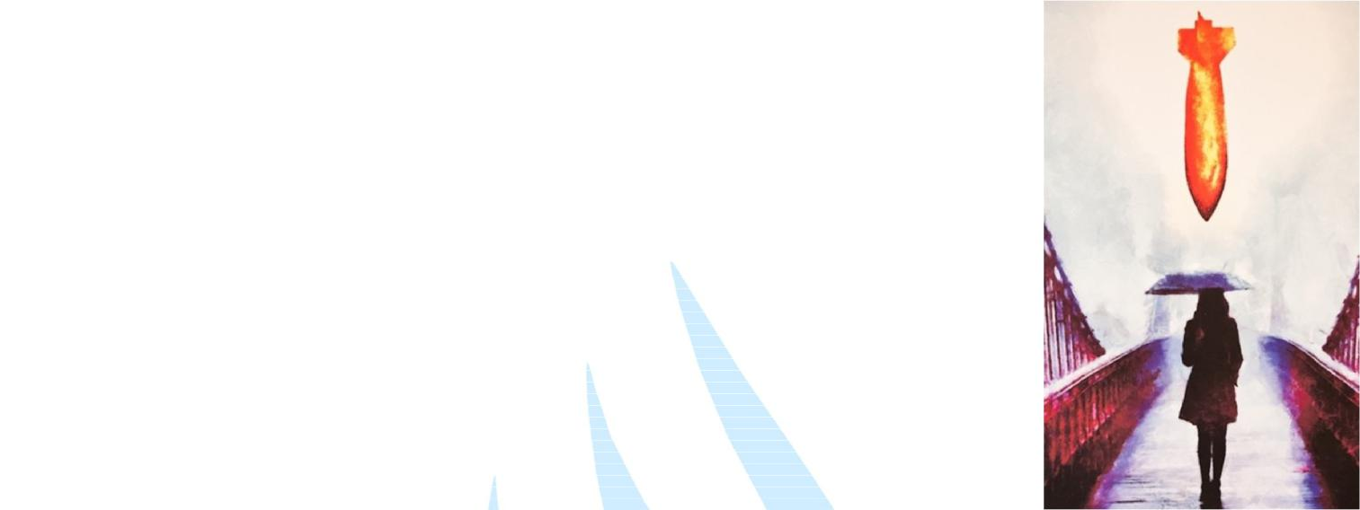
The most vulnerable populations at risk include women and children, who are often killed, raped and sexually abused. Many are forced to become soldiers. Survivors are often displaced, by force or lack of choice, taking refuge in camps where they are often defenseless against armed attacks. Many are maimed by mines and other indiscriminate munitions. Even more die of indirect consequences, disease, malnutrition and famine.
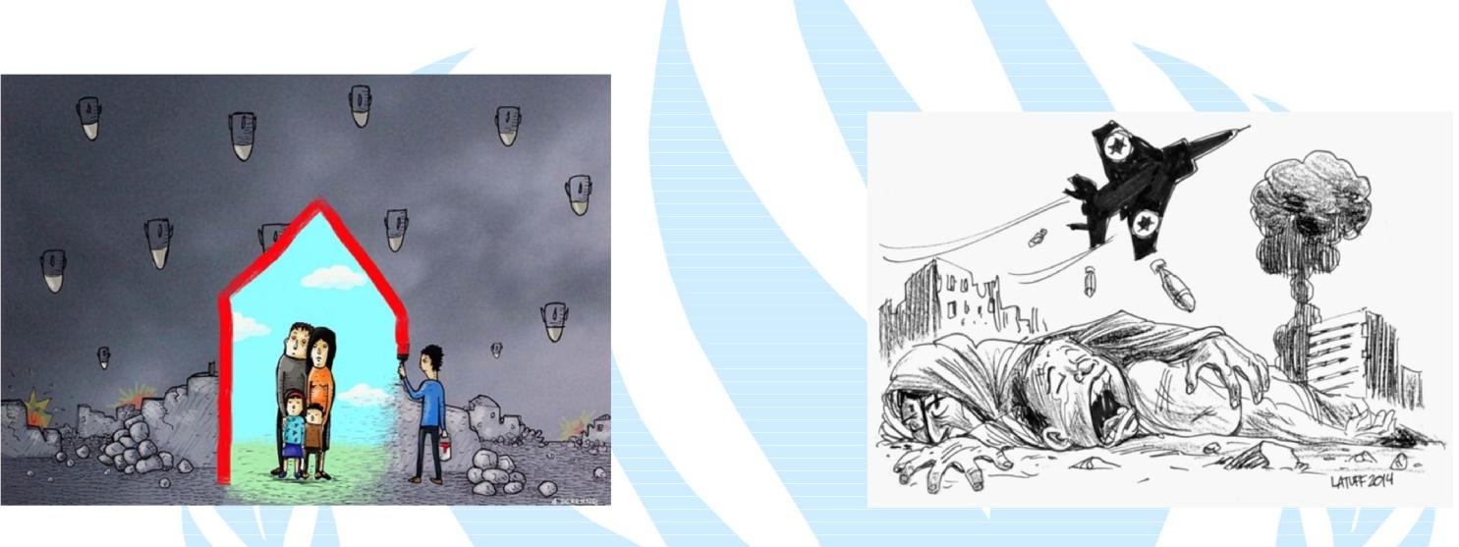

What is civilian protection?

Protection broadly encompasses activities aimed at obtaining full respect for the rights of all individuals in accordance with international law – international humanitarian, human rights, and refugee law – regardless of their age, gender, etc.

In general, protection refers to:
Protection of civilians in armed conflict (POC), whereby all parties to the conflict are responsible for ensuring that the civilian population is respected and protected
Protection in contexts of natural disasters or civil unrest, whereby national authorities have the primary responsibility for the well-being of those affected
Protecting civilians has emerged as a central purpose of many contemporary peace operations. Both civilian and military peacekeepers increasingly recognize the moral duty and operational importance of protecting civilian populations during peacekeeping operations. As peacekeeping missions have grown in number, frequency, size and mandate, the UN has made increasingly concerted efforts to put civilian protection at the

6 | H u m a n R i g h t s C o u n c i l
heart of these operations. There are legal, political, and operational aspects of protecting civilians as well as accompanying challenges.

Protecting civilians is a complex process involving many different actors (international, regional, and local stakeholders) over time (from planning into execution). The challenges to civilian protection are vast, ranging from the scale of the needs on the ground and the challenging security environment, to the lack of infrastructure. Often, lack of operational clarity hampers the ability of UN peacekeepers to protect civilians that suffer the effects of armed conflict.
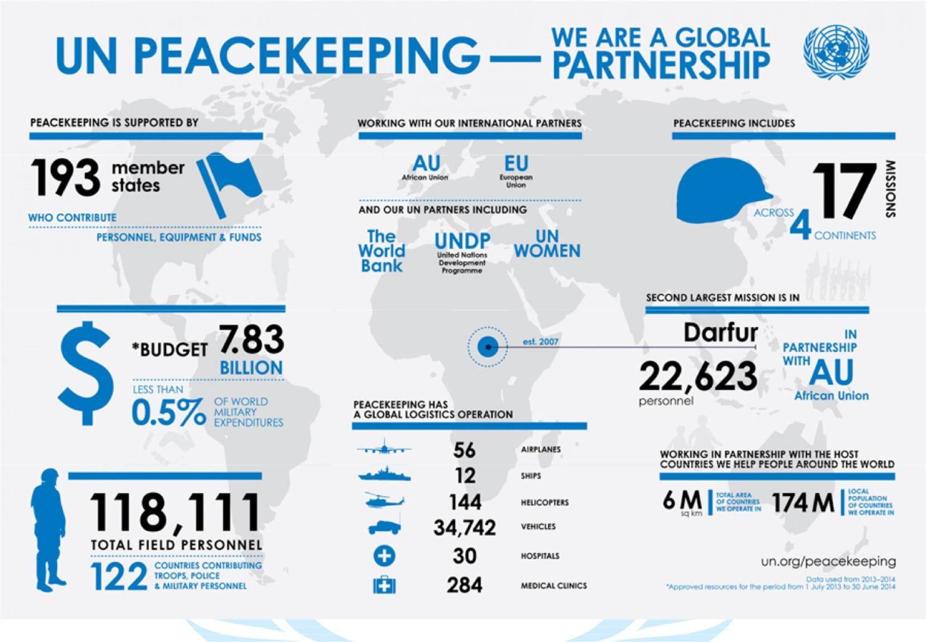

In 1999, the Security Council first requested a dedicated report by the UN Secretary-General on the protection of civilians (POC) in armed conflict, followed by the adoption of a Security Council resolution 1265 to highlight ways to protect civilian populations in armed conflict.

At the normative level, significant progress has been achieved with respect to the protection of civilians over the past decade, but this progress has not consistently translated into more effective and better-coordinated protection efforts on the ground. To this end, the Secretary General identified five core challenges in his 2009 Protection of Civilians report:

7 | H u m a n R i g h t s C o u n c i l
- Enhancing compliance of parties to the conflict with their obligations under international law
- Engagement with non-State armed groups (NSAGs)

- Protecting civilians through UN peacekeeping and other relevant missions
- Humanitarian access

- Enhancing accountability for violations
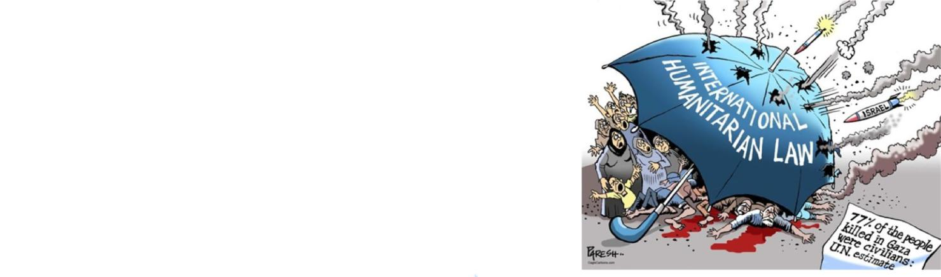
Why Civilian Protection Matters
Civilian protection is essential because it is critical to the perceived success of peacekeeping operations and therefore the UN’s ability to work credibly in the field of peace and security. Many groups deliberately target civilians as a tactic to achieve their political goals, including government forces, armed rebel groups, and terrorist organizations. The security of the population is also a prerequisite for an enduring political arrangement between two warring groups.

Thus, civilian protection is important to the broader political goals of creating and upholding peace agreements. Preventing attacks on civilians also preempts spoilers from creating instability and weakening fragile peace processes in post-war environments.

Moreover, humanitarian assistance cannot be provided by relief agencies, international and regional organizations when they themselves are at risk of being attacked. Hence, the security of civilians is also a key aspect of providing development assistance in post-conflict situations.

On whom does the onus of protection of civilians fall?

It is important to understand that the protection of civilians is not solely the responsibility of UN Peacekeeping operations. It is a systemic effort that includes:
- The Security Council which provides protection of civilians mandates;

- DPKO and DFS, who plan, deploy and manage peacekeeping operations;

- The troops and police contributing countries that provides the personnel for operations;

- The peacekeepers on the ground who implement the mandate provided to them;

- Most importantly, the host government has the primary responsibility for protecting its citizens;

Improving protection of civilians in the context of UN Peacekeeping operations must be addressed holistically, with a view to improving the performance of all actors who share a stake in protecting innocent civilians from physical violence.

8 | H u m a n R i g h t s C o u n c i l
Implications of Armed Conflicts on Civilians in the Affected Zones

Systematic violence and destruction are used as tools to undermine support for insurgent forces. Communities as well as individuals are often targeted in such a way as to destroy unity and fragment social networks. Households are left without breadwinners, the livelihoods of individuals are threatened and the safety of communities and the human rights of individuals are not preserved. Aside from the physical and emotional trauma of these oppressive and deliberate actions, such events have long lasting effects upon the ability of these communities to recover in the wake of armed conflict.

Armed conflict has its greatest socio-economic impact on the poorest communities in the poorest countries, and children and adolescents are among the most severely affected in these communities. The impacts on children may be direct and apparent, as in the case of death, wounding, family separation, or dislocation, but they are frequently far less obvious, as with economic impoverishment, hazardous labor, early marriage, or the loss of opportunities for education and health.
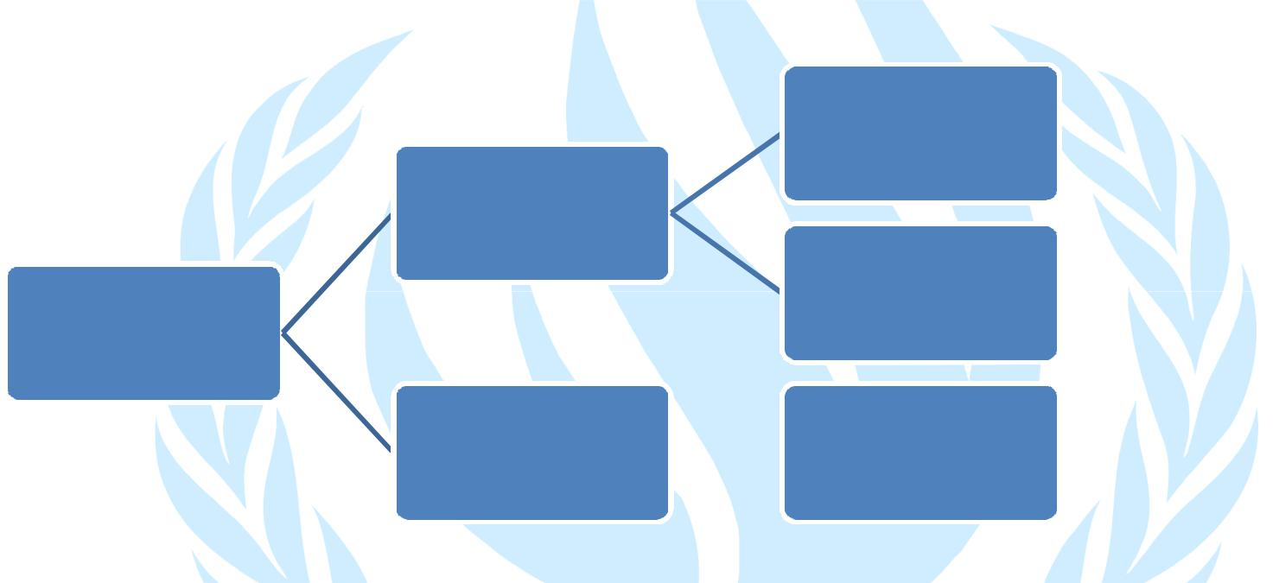

Poverty, decline of economic growth

Displacement(Refugee's

and Internally Displaced people)

Sexual, Gender based violence
Loss of life and property

Prolonged psychological |  | Impact on education,
trauma |  | occupations

Internally displaced people/ refugees

Displaced migrant communities emerge, by definition, out of crisis. Impacts on neighboring countries are not limited to these population movements and there may be multiple effects on social cohesion and economic opportunities. Additionally, the neighboring countries may incur new costs in relation to refugees and losses from deteriorating regional trade. This has resulted in reluctance from the host countries with regard to the acceptance of refugees.

Only a small proportion of those who are displaced are officially registered and in receipt of -humanitarian assistance. Amongst several factors, non-acknowledgement of professional skills, language difficulties, lack of social networks, and deliberate obstruction by local and national authorities hinder the ability of displaced populations to access regular employment. As a consequence they tend to occupy the most menial and poorly paid jobs, in which the opportunities for collective organization, self-representation and self-advocacy are few and the dangers of exploitation and abuse.

9 | H u m a n R i g h t s C o u n c i l
Border Disputes

India-Pakistan Border dispute has resulted in widespread displacement of people. The Arab Spring is another widely cited case of displacement of refugees.
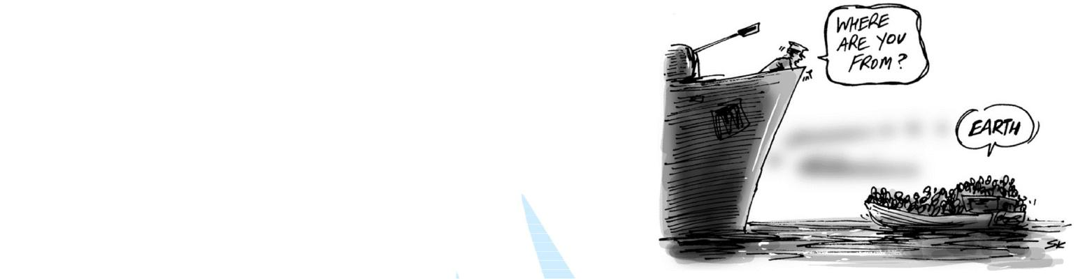
There are often complex cross-border links at different levels and between different actors, this includes cross-border operations of armed opposition groups, the international and local arms trade, and the sale of natural resources, narcotics, and other commodities used to sponsor conflict. Countries bordering conflict zones may need to increase security expenditure in military and non-military sectors.

Civilian Deaths over the years
Although the number of battle deaths due to actual military engagement has decreased, yet the total number of war deaths, which includes both battle and non-battle deaths has remained high. For example, in the Democratic Republic of Congo, there were 2.5 million war deaths between 1998 and 2001, yet only 350,000 of those people were killed in actual battle. In addition, the individuals who are injured due to armed conflict are proportionally high. This has long term socio- economic implications on the life of the individual, the society and the nation.
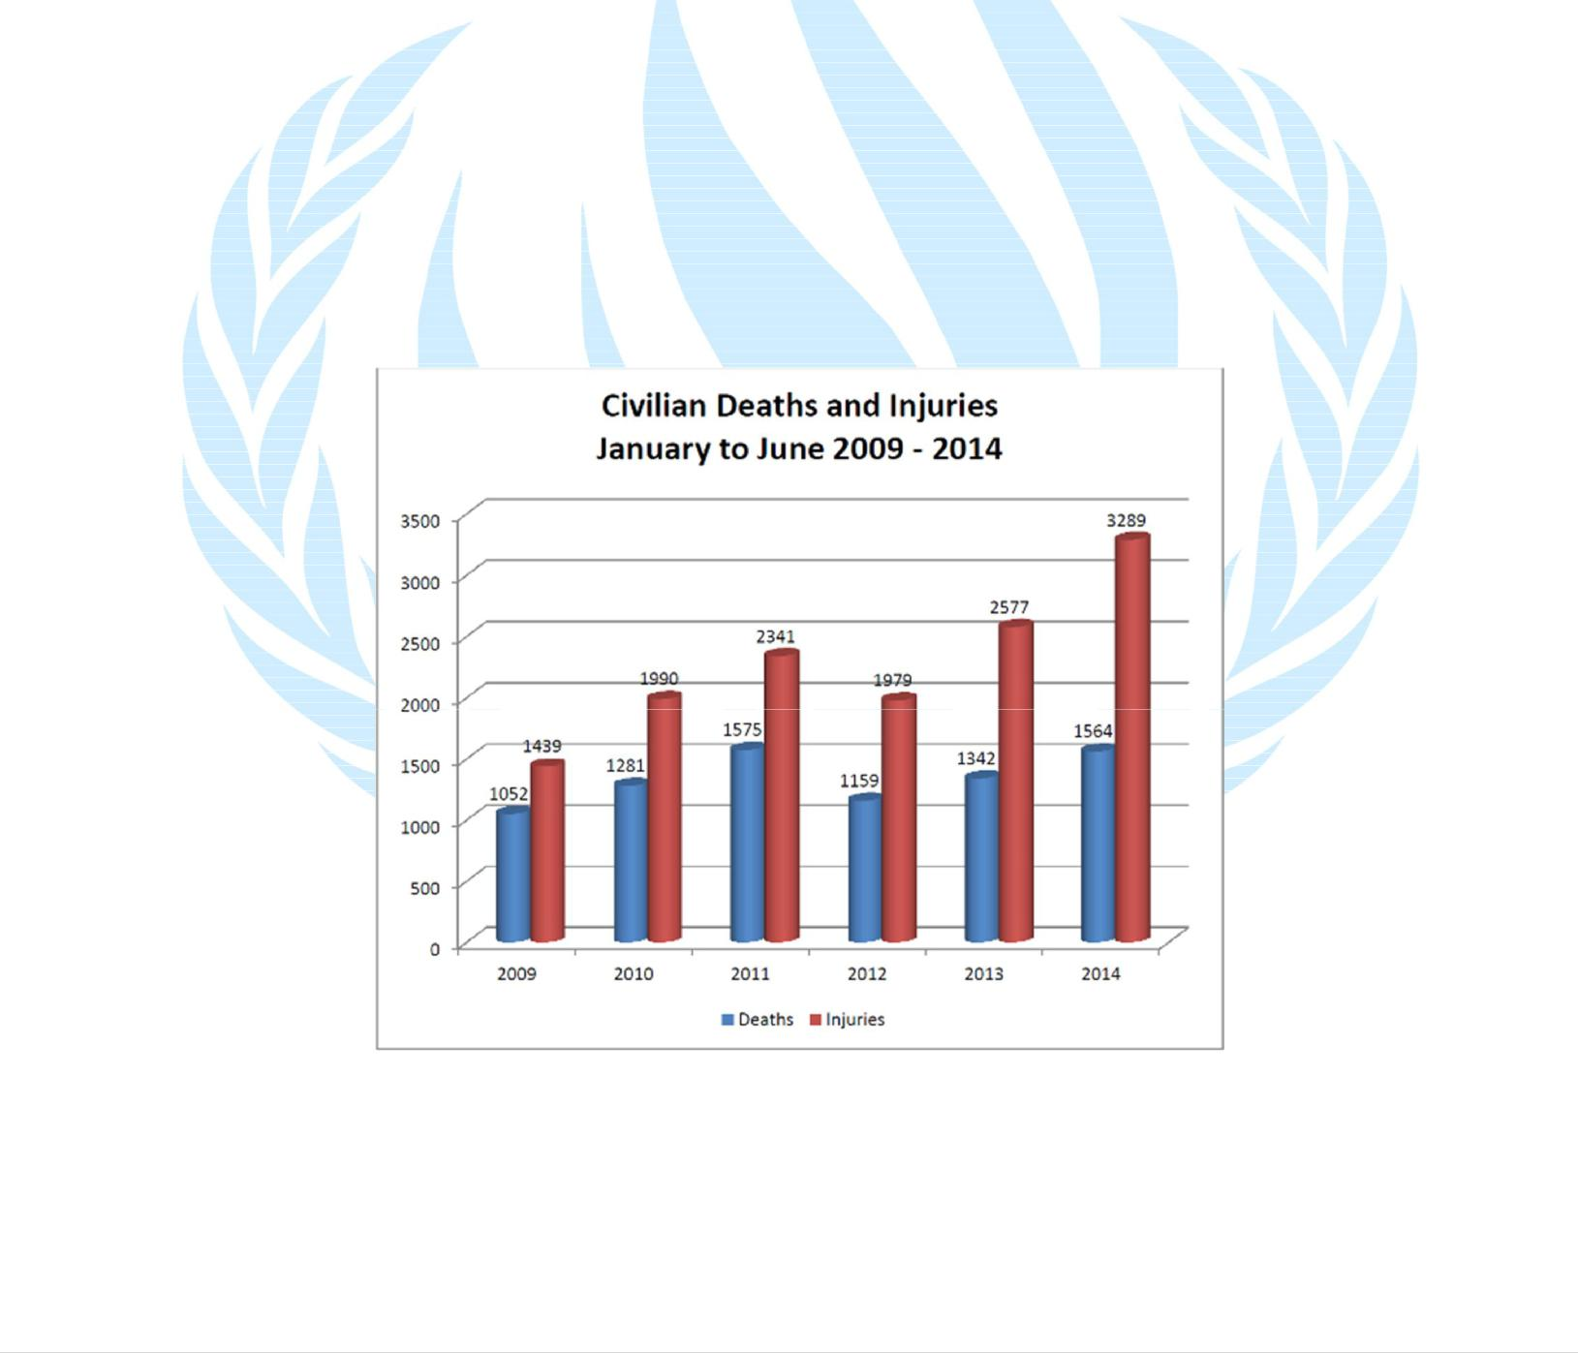

10 | H u m a n R i g h t s C o u n c i l
Terrorism
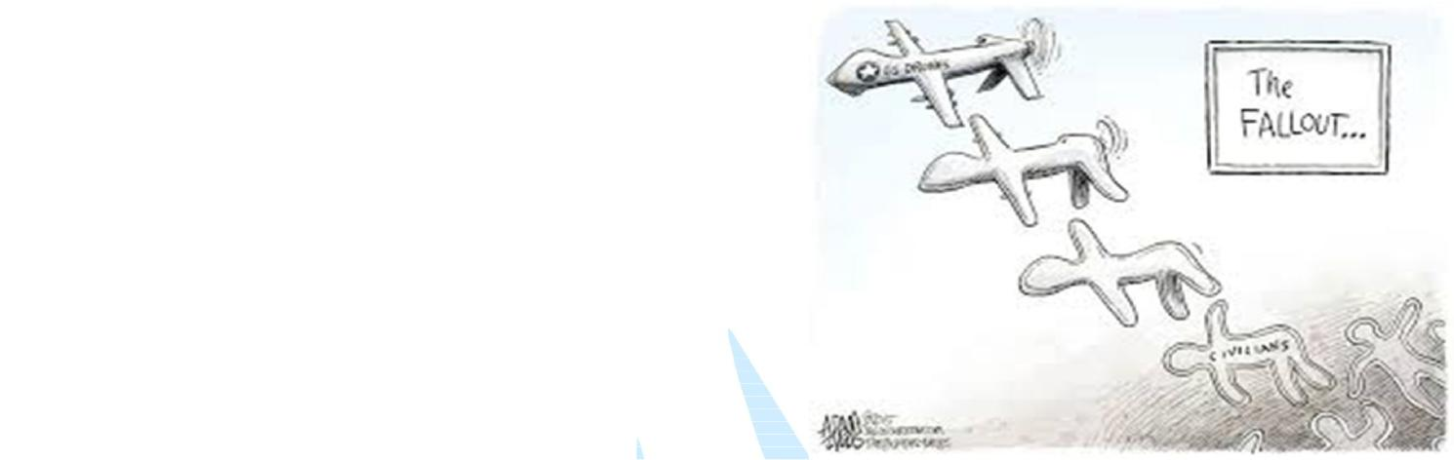
Terrorism, originating at the hands of non-state actors is often countered by means of drone strikes. These may, at times misfire, and put civilians in harm’s way.

Child exploitation/abuse
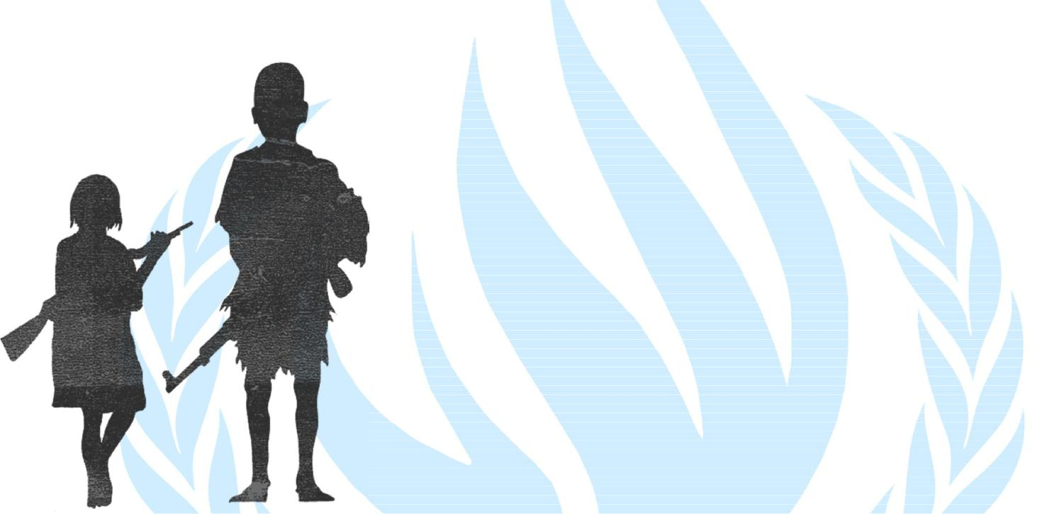
Children are a major target of conflict and violence. The primary concern for children in conflict zones is their physical safety. The hazards associated with armed conflict range from being accidentally caught in the crossfire, bombing and shelling and communal massacres, to landmines, which children are particularly vulnerable due to their generally smaller stature and the proximity of vital organs to the body surface.

In a significant number of conflicts, including in Uganda, Rwanda, Sierra Leone, Angola and Mozambique there has been the forced recruitment of child soldiers through, among other things, abductions.

Crimes against women
Gender-based inequity leads to higher mortality and morbidity among females during armed conflict. Some reasons for this are:
- Violence against girls and women, including rape and sexual slavery;

- Hunger and exploitation in camps for refugees and internally displaced persons, when men take control of food distribution;
- Malnutrition, when food aid neglects women's and children's special nutritional requirements; and

- Culturally inappropriate and/or inadequate access to health services.


11 | H u m a n R i g h t s C o u n c i l
Conclusion

These threats have physical, socio-economic and psychological impacts. However, these are often only measured in terms of their economic implication.

This is not correct, considering that Landmines, that are designed to maim, can have severe psychological impacts on those affected. For example, due to prejudice and cultural factors in some communities, injured unmarried women may have reduced opportunities to marry and have children. Further, landmines are cheap to use but extremely expensive to decommission. A single mine can often be bought on the black market for US$3, but may cost anything between US$200-1 000 to remove, depending on where it is placed.
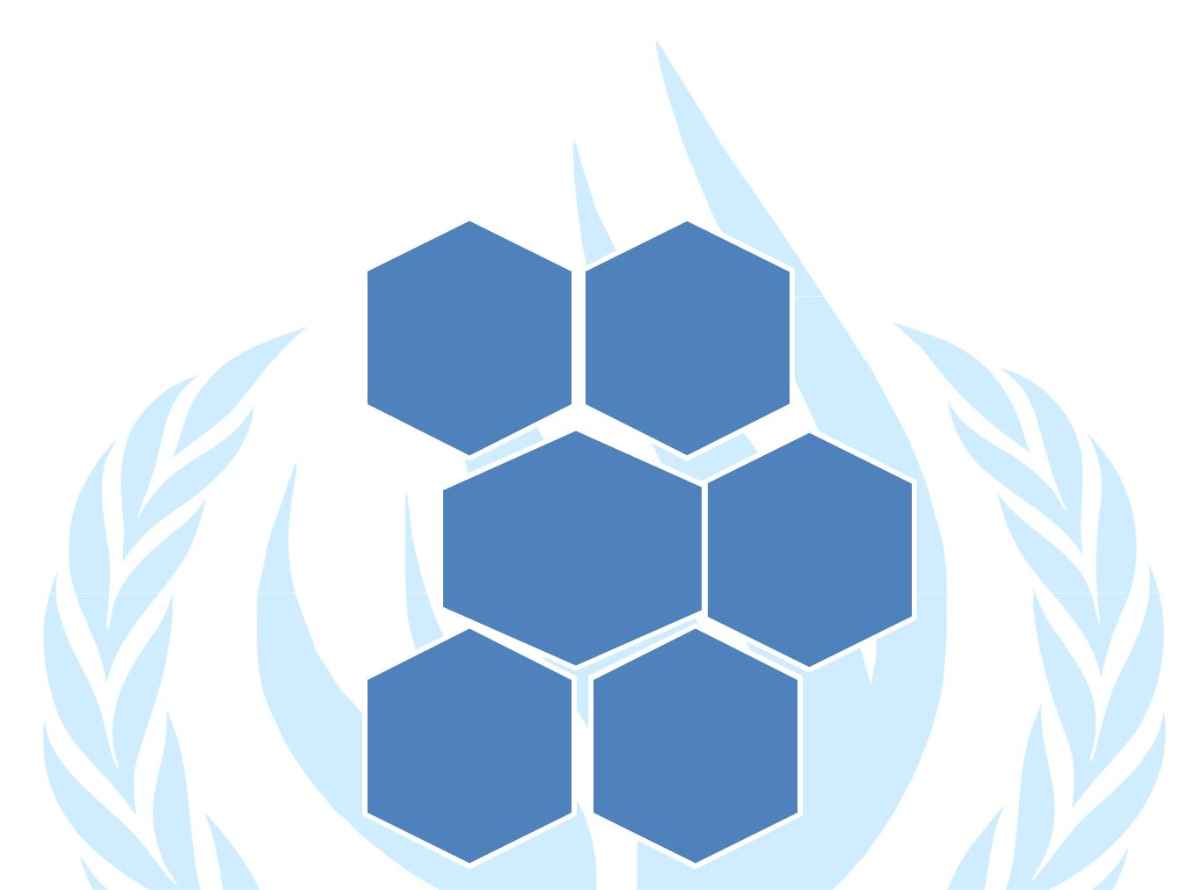

Weapons of mass destruction

Small
Arms

THREATS
TO Landmines
CIVILIANS

Human
Shields

Drones

12 | H u m a n R i g h t s C o u n c i l

Solution Oriented Approach

Some armed conflicts have had a more or less immediate impact on the development of humanitarian law. World War I witnessed the use of methods of warfare that were, if not completely new, at least deployed on an unprecedented scale. These included poison gas, the first aerial bombardments and the capture of hundreds of thousands of prisoners. The treaty of 1925 prohibiting the use of certain methods of warfare and the treaties of 1929 dealing with the treatment of prisoners of war were a response to those developments.
World War II saw civilians and military personnel killed in equal numbers, as against a ratio of 1:10 in the World War I. In 1949, the international community responded to those tragic figures, and more particularly to the terrible effects the war had on civilians, by revising the Conventions then in force and by adopting a new instrument: the Fourth Geneva Convention for the protection of civilians.

In 1977, the Additional Protocols were a response to the new challenges for protection in decolonization wars as well as to the development of new military technology. In particular, the Additional Protocol II includes also dissident armed forces or other organized armed groups which, under responsible command, exercise control over a part of the territory.
Principal Instruments of International Humanitarian Law and Other Related Instruments -

1864 Geneva Convention for the amelioration of the condition of the wounded in armies in the field 1868 Declaration of St. Petersburg (prohibiting the use of certain projectiles in wartime)
1899 The Hague Conventions respecting the laws and customs of war on land and the adaptation to maritime warfare of the principles of the 1864 Geneva Convention
1906 Review and development of the 1864 Geneva Convention

1907 Review of The Hague Conventions of 1899 and adoption of new Conventions

1925 Geneva Protocol for the prohibition of the use in war of asphyxiating, poisonous or other gases and of bacteriological methods of warfare
1929 Two Geneva Conventions:

  - Review and development of the 1906 Geneva Convention

  - Geneva Convention relating to the treatment of prisoners of war (new) 1949 Geneva Conventions:
  - I: Amelioration of the condition of the wounded and sick in armed forces in the field

  - II: Amelioration of the condition of wounded, sick and shipwrecked members of armed forces at sea
  - III: Treatment of prisoners of war

  - IV: Protection of civilian persons in time of war (new)

1954 The Hague Convention for the protection of cultural property in the event of armed conflict

1972 Convention on the prohibition of the development, production and stockpiling of bacteriological (biological) and toxic weapons and on their destruction
1977 Two Protocols additional to the four 1949 Geneva Conventions, which strengthen the protection of victims of international (Protocol I) and non-international (Protocol II) armed conflicts
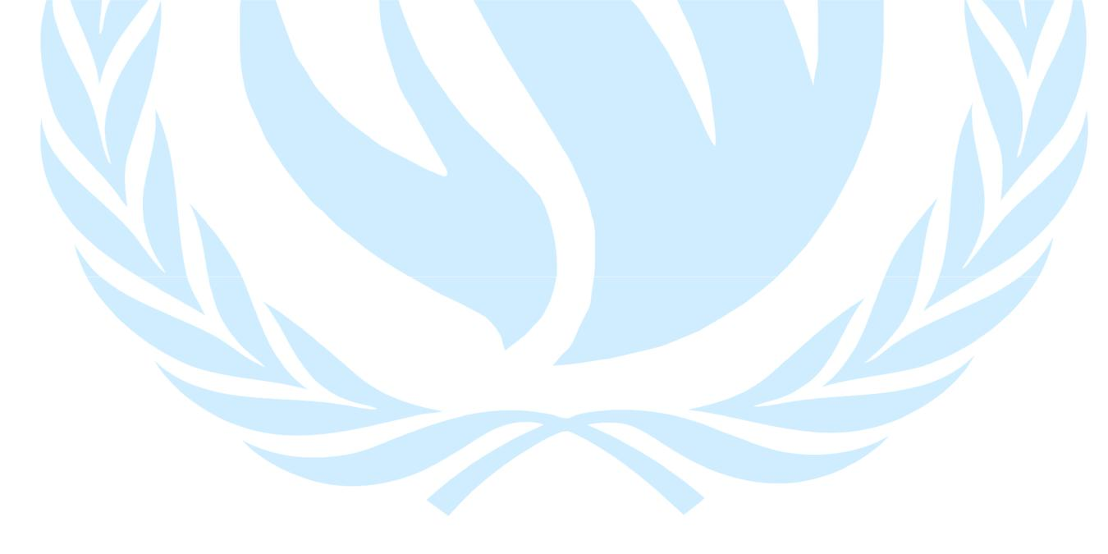
13 | H u m a n R i g h t s C o u n c i l
Important tips for research

- What is international humanitarian law?

- What are the essential rules of international humanitarian law?

- What are the origins of international humanitarian law?

- What treaties make up international humanitarian law?

- Who is bound by the Geneva Conventions?

- What are jus ad bellum and jus in bello?

- In what situations does humanitarian law apply? For
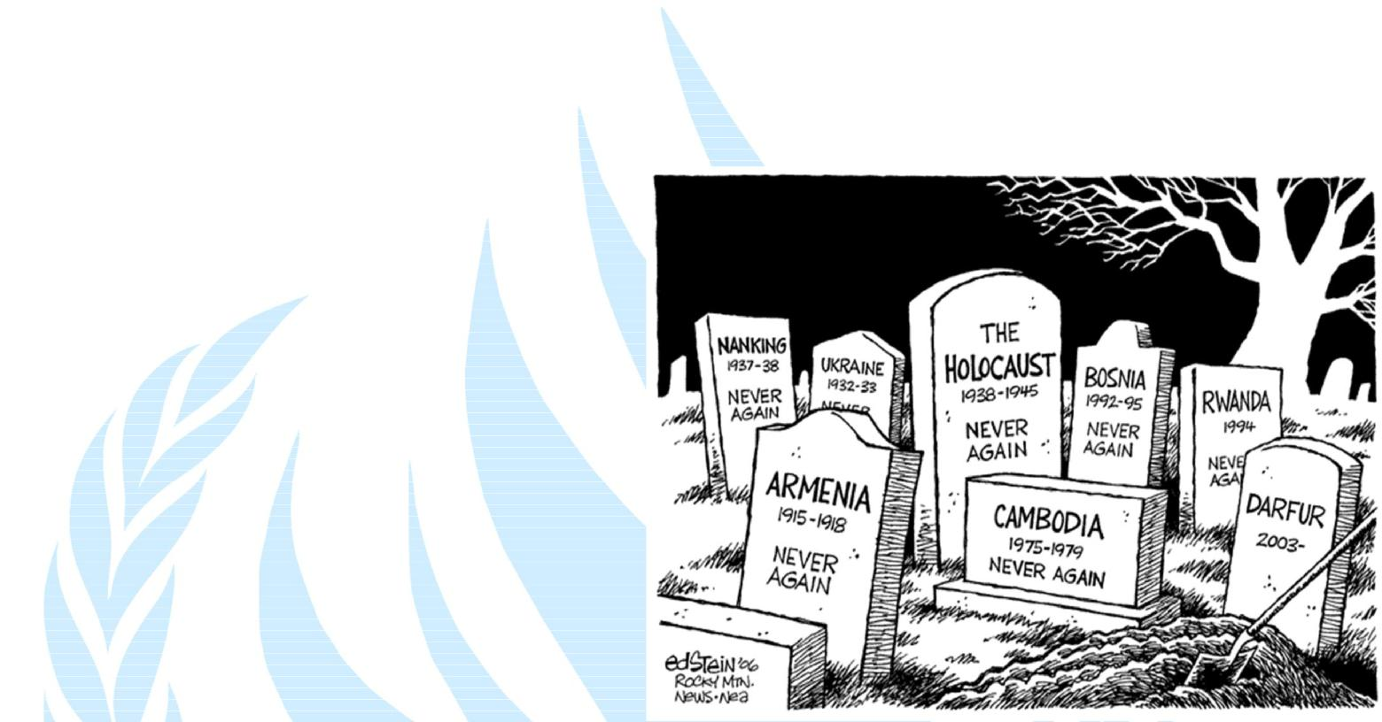
who is it intended and who does it protect?

- Does humanitarian law apply to the “new” conflicts?

- How does humanitarian law adapt to new developments?

- What does humanitarian law provide for in terms of material assistance to the victims of armed conflict?

- What does humanitarian law say with regard to the restoration of family links?

- What are the provisions of humanitarian law governing use of the emblem?

- How does humanitarian law protect refugees and internally displaced persons?

- What measures are available for implementing humanitarian law?

- How are war criminals prosecuted under humanitarian law?

- What is the difference between humanitarian law and human rights law?

- Does humanitarian law apply to peace-keeping and peace-enforcement operations carried out by or under the auspices of the United Nations?

- What does humanitarian law say about terrorism?


14 | H u m a n R i g h t s C o u n c i l

